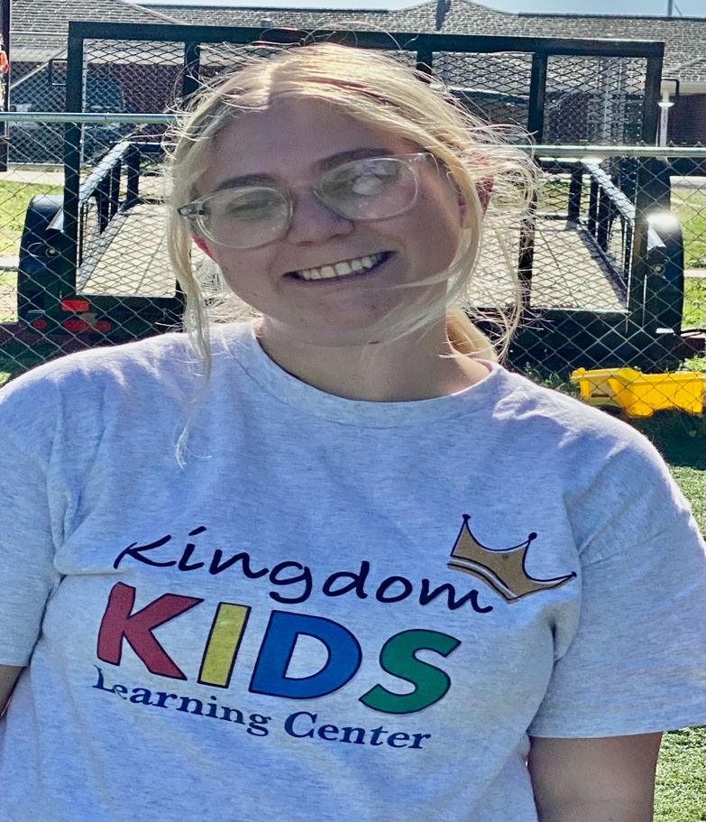
Toddler
Classroom
_____________________
18 Months
To
2 years old

Background
Cara Dyess was born and raised in Kingsland, Texas. I am passionate about working with children and supporting their growth and development. I am dedicated to making a positive impact in the lives of young learners and their families.
Family
I am a proud mother of two children, ages 4 and 3, which gives me a special understanding of the importance of a safe and nurturing environment for young learners. In my free time, I enjoy spending time with my childhood dog, Sadie, and going for drives in my Jeep.
Professional experience
I am beginning my career in childcare and passionate about working with young children. As a mother of two, I understand the importance of patience, care, and creating a nurturing environment where children can learn and grow.
Mission and vision
My goal as a teacher is to create a safe, caring, and welcoming environment where every child feels valued and supported. I want to encourage children to explore, learn, and build confidence while helping them grow socially, emotionally, and academically. I also hope to build strong relationships with families and inspire a love of learning in every child.

